**DAILY ONLINE ACTIVITIES SUMMARY**

|  |  |  |  |  |  |  |  |
| --- | --- | --- | --- | --- | --- | --- | --- |
| **Date:** | 05/06/2020 | | | | **Name:** | AMBIKA V | |
| **Sem & Sec** | 4th Sem Section'A' | | | | **USN:** | 4AL18CS005 | |
| **Online Test Summary** | | | | | | | |
| **Subject** | | No test | | | | | |
| **Max. Marks** | | **-** | | **Score** | | **_** | |
| **Certification Course Summary** | | | | | | | |
| **Course** | JAVA PROGRAMMING | | | | | | |
| **Certificate Provider** | | | greatlearning academy | **Duration** | | | 3.5 hrs |
| **Coding Challenges** | | | | | | | |
| **Problem statement 1:** Write a Java Program to find the duplicate characters in a string. | | | | | | | |
| **Status:** completed | | | | | | | |
| **Uploaded the report in Github** | | | | yes | | | |
| **If yes Repository name** | | | | https://github.com/ambika0202/lockdown-coding- | | | |
| **Uploaded the report in slack** | | | | yes | | | |

**ONLINE TEST DETAILS: N/A**

**CERTIFICATION COURSE DETAILS:**

**Name of the course**: Java Programming

**Certificate Provider**: Great Learning Academy

In this Java programming course ,today I have continued to learn new topics and this topic is about the Flow control statements and Functions in Java.

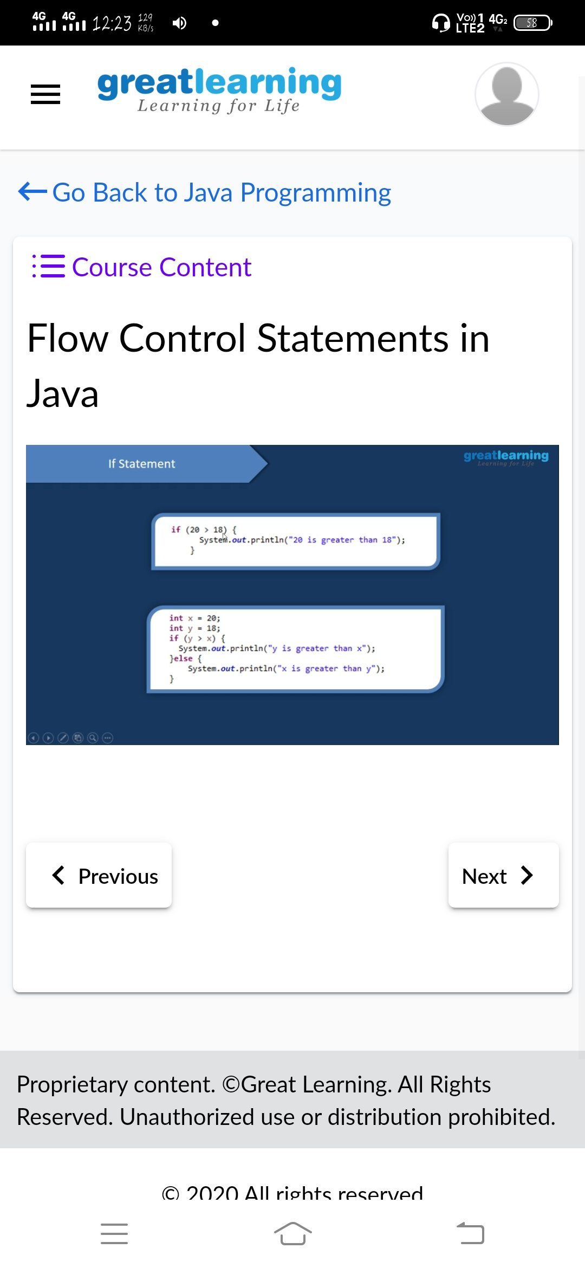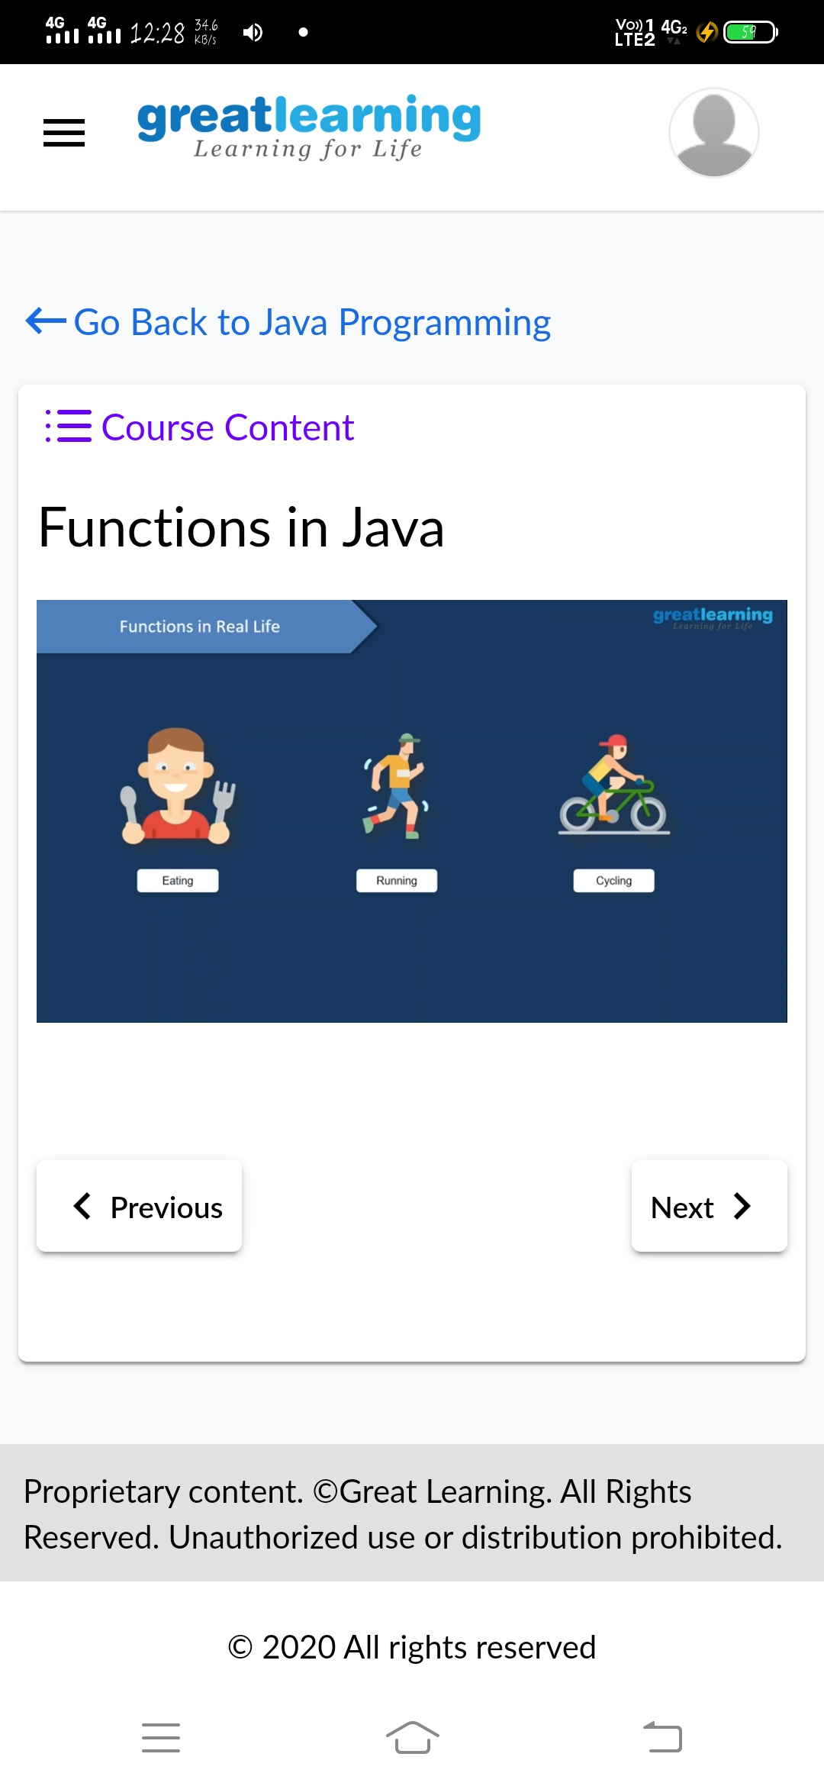

**CODING CHALLENGES DETAILS**: Every day we are given with new question of coding related to the language of java and c.

**Problem statement 1:** Write a Java Program to find the duplicate characters in a string.

